CIRRASPEC Collection Site  
User’s Manual

System Version: 3.0

Revision History

|  |  |  |  |
| --- | --- | --- | --- |
| **Document Version** | **Date** | **Name** | **Description** |
| 1.1 | 1/03/2012 | Robin Petros | Initial publication for 1.1 Release. |
| 1.1.3 | 5.01/2012 | Robin Petros | Revised for 1.1.3 Release. |
| 1.1.4 | 09/20/2012 | Robin Petros | Revised for 1.1.4 Release, and added Note to all sections re: login location determines what records are accessed. |
| 1.2 | 07/27/2015 | Siddhi Jadhav | Revised for 1.1.8 Release. Added PHI authorization feature. |
| 2.0 | 06/06/2016 | Siddhi Jadhav | Revised for CIRRASPEC (version 2.0). |
| 3.0 | 28/12/2017 | Sayali Dev | As per Current cirraspec version:  Added CRN Workflow and navigating through app section.  Reorganized sections to navigate as per the CRN workflow.  Added Alternative paths, notes, screenshots  Updated steps and details |

**Table of Contents**

Revision History 2

Accessing the Application 4

Login Guidelines 4

Logging into the Application 4

Logging off the Application 5

Accessing the Home Page 6

Accessing the My Account Page 7

To set user profiles on My Account page : 8

Site Settings 8

Changing Your Password 8

Navigating through the application: 9

Workflow for Clinical Research Nurse – At Collection site 10

Receiving a Kits Shipment 11

Viewing a List of Kit Shipments 11

Recording Receipt of a Kits Shipment 12

Creating/Maintaining a Subject Record 16

Enrolling a Subject / Donor: 16

Updating a Collection Event for a New Subject 18

Assigning a Kit to a Subject 19

Collect Specimens as mentioned in the Assigned Kit 21

Completing Collection Forms for a Subject 23

Adding an Unscheduled Collection Event for a Subject 27

Recording the Use of a Kit 28

Viewing a List of Kits 28

Recording the Use of a Kit 30

Creating and Sending a Shipment of Collected Biospecimens 35

Creating a Shipment 35

Modifying a Shipment 39

Deleting a Shipment 41

Sending a Shipment of Collected Samples 42

# 

# Accessing the Application

To access the CIRRASPEC application, you must have a valid user name and password.

### Login Guidelines

* The password must contain a minimum of six characters and is case sensitive.
* The password must contain at least one alphabet, one number and one special character such as !, @, #, &, etc.
* The application prompts you to change your password after you login for the first time. For more information about how to change your password, see **Changing Your Password**.
* This application supports the following browsers:
  + Firefox 3.5 and above
  + IE 8.0 and above
* You must not run IE 8.0 in the Compatibility mode. You can check the IE compatibility view by clicking **Tools** > **Compatibility View settings**.
* You must ensure that any pop-up blocker software is turned off.

## Logging into the Application

To log in:

1. Enter CIRRASPEC web site URL In the address bar of a Web browser.

The **Login** page appears.

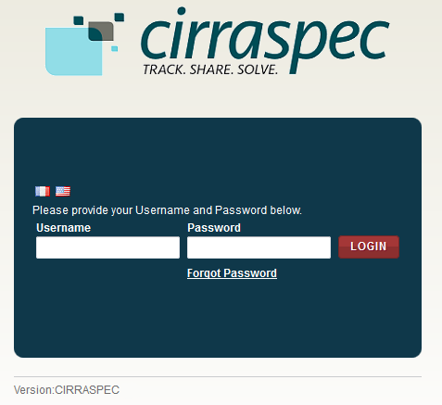

1. In the **Username** box, type your username and in the **Password** box, type your password.

**Note:**

If you have forgotten your login credentials or need login assistance, send an e-mail to [cirraspec@tgen.org](mailto:Bio4Dhelp@tgen.org).

1. Click **Login**.

The CIRRASPEC **home page** appears.

On top right, below the My Account link, Home page displays Welcome note:“Welcome User Sitename”

**Note:**

* If you have more than one assigned collection site locations, you are prompted to select the appropriate location for this Web session.
* Click on **SAVE,** the home page displays the location selected on top right Welcome note.

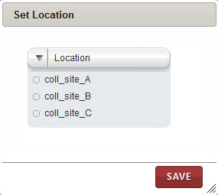

## Logging off the Application

To log off from the application, in the upper-right corner of any page, click the **Logout** link.

On successful logout, The **Login** page appears.

## Accessing the Home Page

You can access the CIRRASPEC home page from any other page by clicking the **Home** tab.

1. Allows you to access the CIRRASPEC home page
2. Allows you to access your account for password and user profile maintenance
3. Welcome note displaying user logging to the site
4. Allows you to log off from the application.
5. Easy Access Links

3

4

2

1

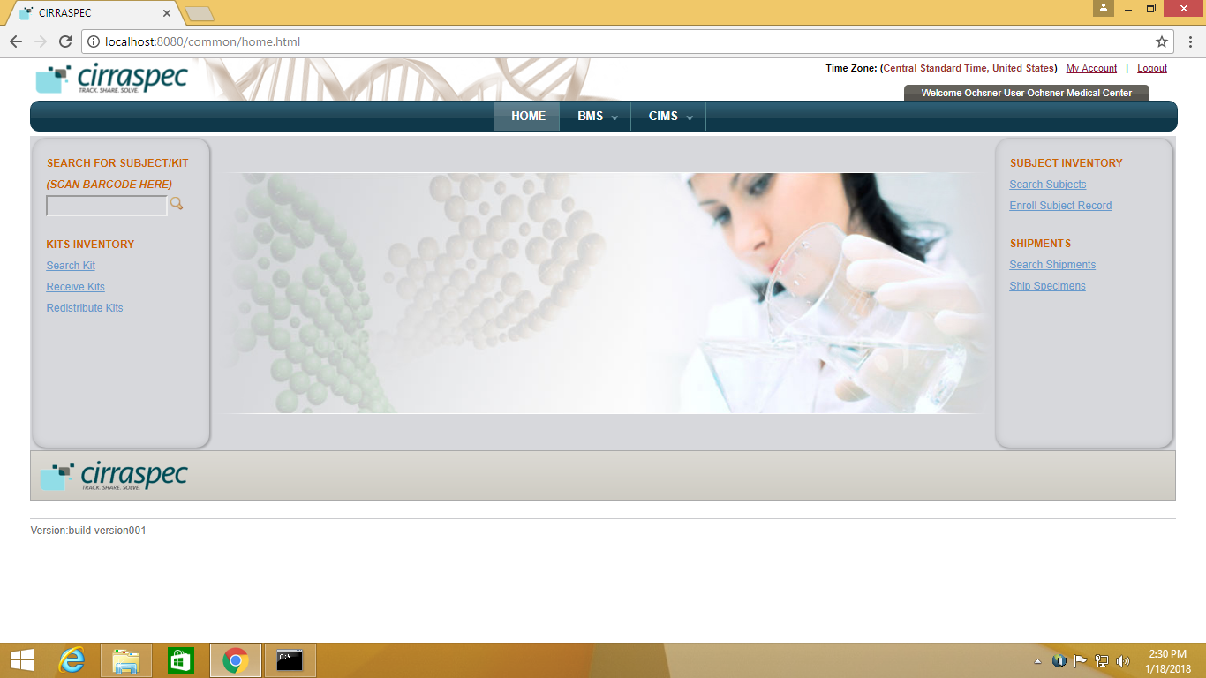

5

5

## Accessing the My Account Page

You can use the My Account page to update your user profile (language and location preferences) and your login password.

To access the **My Account** page:

1. In the upper-right corner of any page, click the **My Account** link.

The **My Account** page appears.

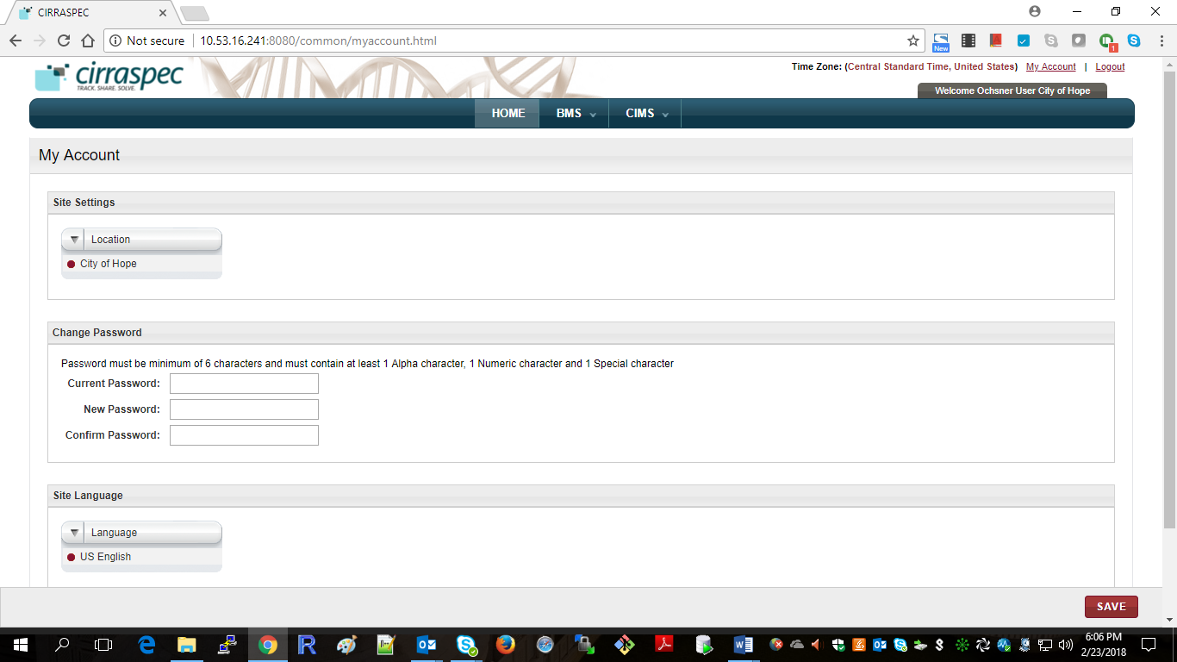

### 

### To set user profiles on My Account page :

### Site Settings

Allows you to select a different collection site location to view information and perform tasks associated with that location.

To select a different location:

1. Click on the **Location** list dropdown arrow.

Locations list displays all locations assigned to you based on your user role and access permissions.

1. Select the desired location.
2. Click **SAVE**.

The location is updated. Information associated with that location is displayed on the CIRRASPEC pages.

### Changing Your Password

Allows you to update the password for login to Cirraspec application.

Password Guidelines:

* The password must contain a minimum of six characters and is case sensitive.
* The password must contain at least one alphabet, one number and one special character such as !, @, #, &, etc.

To change your password:

1. In the **Current Password** boxof the **Change Password** area, type your current password.
2. In the **New Password** box, type a new password.
3. In the **Confirm Password** box, type the new password again.
4. Click **SAVE**.  
   Your password is changed.

**Note:** For assistance with the username or password, send an email to [cirraspec@tgen.org](mailto:Bio4Dhelp@tgen.org)

# Navigating through the application:

BMS tab:

|  |  |  |
| --- | --- | --- |
| Tab | Function | Events: |
| Kits Inventory | Allows to perform kit related activities. | Search kits, modify kit contents, generate reports, print labels, download forms. |
| Kits Shipment | Allows to receive kits shipments | Receive shipment, Search Shipments |
| Shipments | Allows to ship kits from collection site to biobank sites. | Create kits shipment, send shipment,  Modify/delete kits shipments |

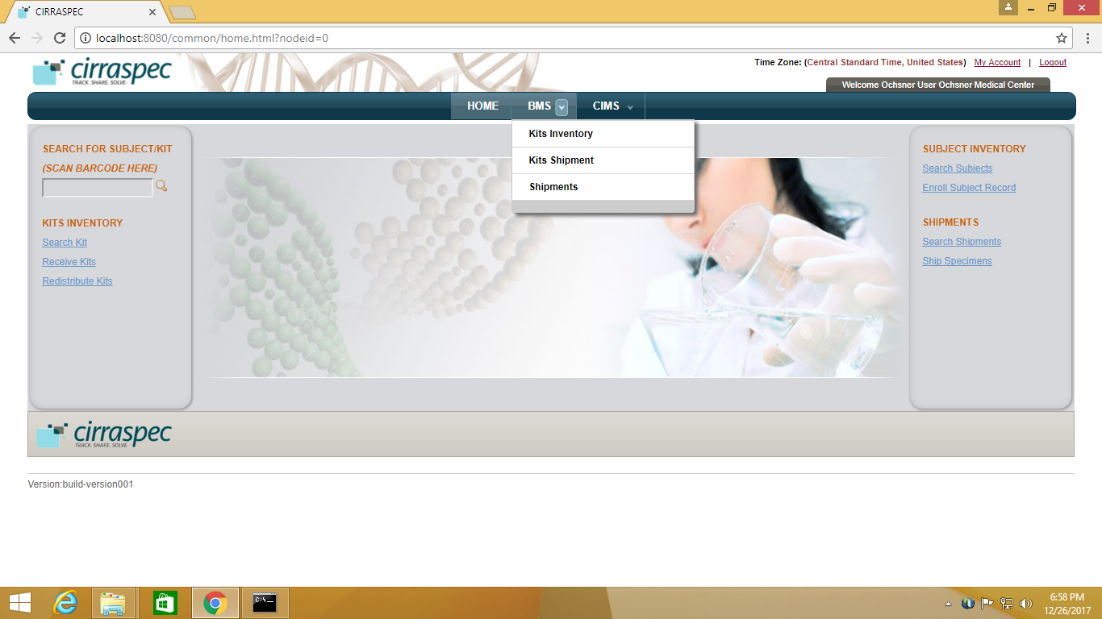

CIMS tab:

|  |  |  |
| --- | --- | --- |
| Tab | Function | Events |
| Subject Centric View | Allows subject /donor / patient mangement | Update forms, assign kits to collection events, collect subject specimens, download reports. |

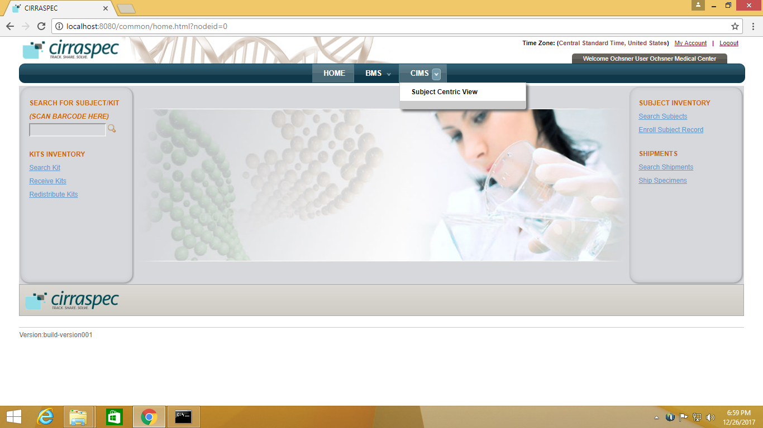

# NOTE: You can scan barcode for the specimen /kit to enter source identifiers into the application.

# Workflow for Clinical Research Nurse – At Collection site

Receive a kits Shipments from Biobank on page 11, 12

Enroll donor or Subject to the collection on page 16

Assign kits to Subject on page 19

Collect specimens for Collection Events as per the kits on page 21 or 28

*

Update the Collection forms data on page 23

Ship the Kits back to Biobank on page 35 - 42

For Unscheduled Events:

Adding an unplanned collection event on page 27

Collect specimens not in Kit on page 30

Send kits from one collection site to other collection site on page

**\* NOTE :**

Recording Use of Kit is required to be done once.

Either from Subject centric page as on page 20 or from Kit view page as on page 27

# Receiving a Kits Shipment

### Viewing a List of Kit Shipments

To view a list of kit shipments:

1. Log in to Cirraspec using your credentials.
2. Point to the arrow of the **BMS** tab, and then click **Kits Shipment**.   
   The **Kit Shipment Search** page appears.
3. Click **SEARCH**.  
   The kit shipment search page displays a list of all kit shipments.

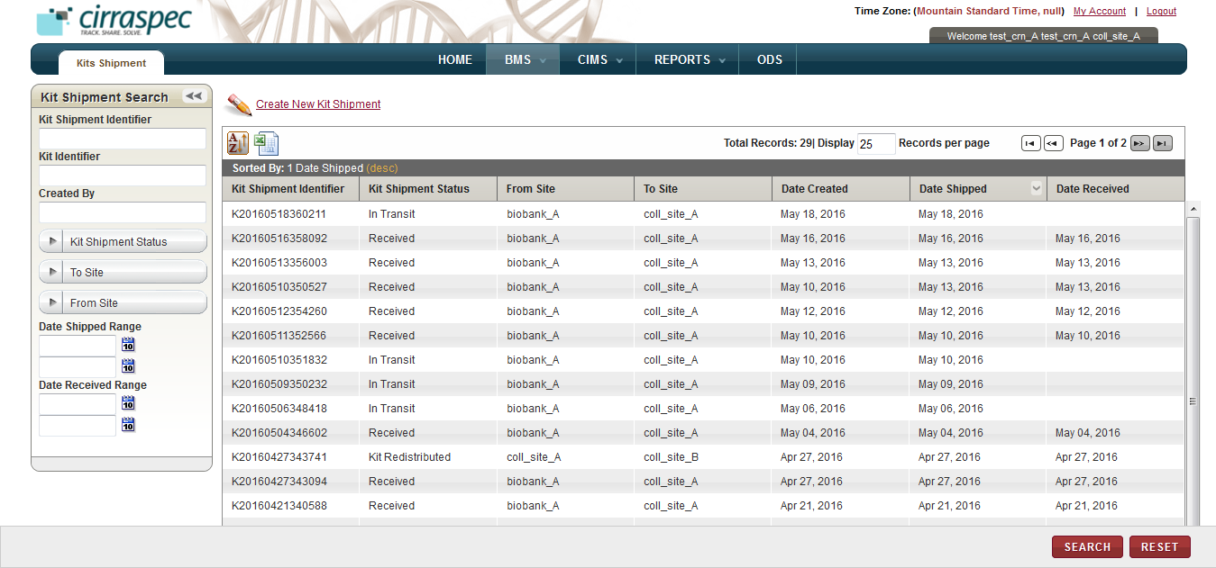

1. To search for a specific shipment, type the Identifier of the kit shipment in the **Kit Shipment Identifier** box. Or specify other search criteria by completing one or more fields in the **Kit Shipment Search** pane.

**Note:**

* You can use one field or a combination of fields to search for a kit shipment.
* You can type the full or partial value in a search field along with an asterisk (*) before or after the partial value. For example, if you type **02\***, you obtain records that begin with 02. If you type **\*02**, you obtain records that end with 02

1. Click **SEARCH**.

### Recording Receipt of a Kits Shipment

To receive a kits shipment:

1. On the **Kits Shipment Search** page, click the row of the “In Transit” kit shipment that you want to receive.

The **View Kits Shipment** page appears with the details of the kit shipment that you selected.

1. Click **RECEIVE**.

The **Receive Kits Shipment** page appears.  
**Note:** Fields that are marked with the red asterisk (*) are mandatory.

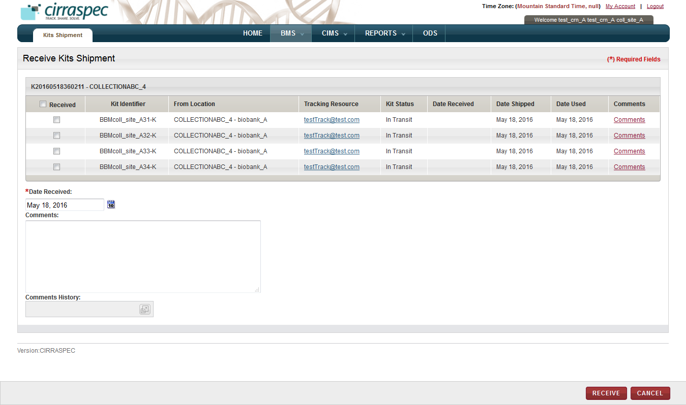

1. Select the check boxes in front of the kits that you want to receive.

**Note:** You can record receipt of all kits now, or only selected kit(s) and return later to receive other kits in this shipment. To receive all the kits now, select the checkbox in the header next to **Received**.

1. If the kit was received on a date other than the date displayed in the **Date Received** box, click the date icon Search calendar and then click on the date when the kit was received.
2. Type Comments, as needed.
3. Click **RECEIVE**.

The **View Kits Shipment** page appears.

On right panel, For each kit received, Kit Status appears as **Received - Not Used.**

Under View Kits Shipment, Kit Shipment Status appears as **Received – Partial** if some kits of the shipment are received else **Received** is shown on receiving all kits of shipment.

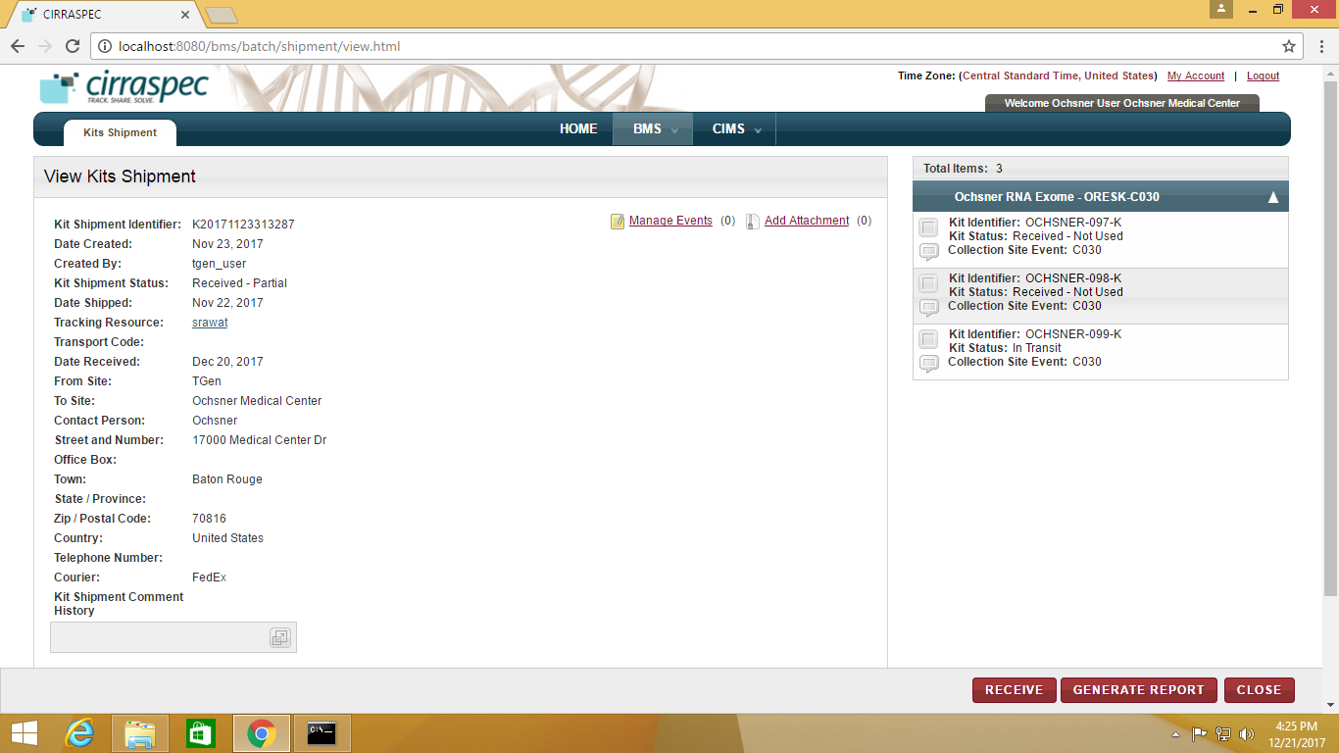

**Note:**

To receive unreceived kits from this shipment, Click Receive and Repeat steps 3 to 5 above.

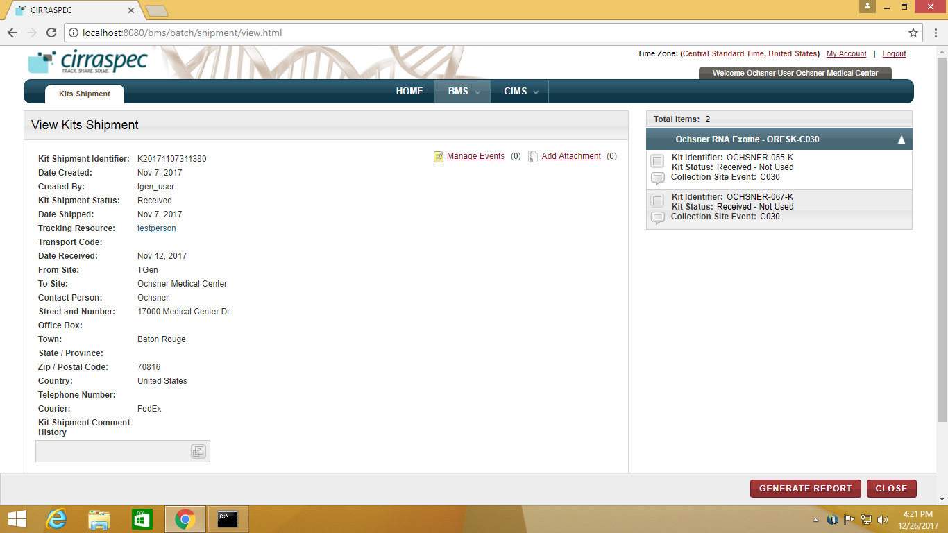

1. To generate a report of the Kit contents, click **GENERATE REPORT**.

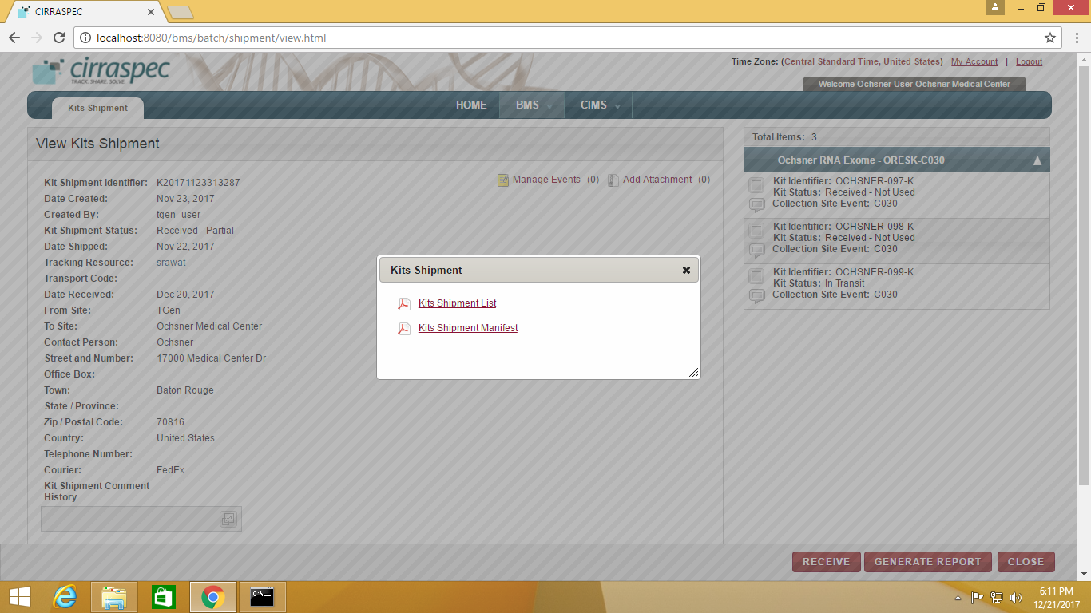

1. On pop-up shown, select one of the following:

**Kits Shipment List** to display a report listing the shipment contents.

**Kits Shipment Manifest** to display a report listing the contents and all shipment details.

1. Click on **CLOSE** to return to Home Page.

*Alternative Path:*

1. Log in to Cirraspec using your credentials.
2. On Home Page, Click on **Receive Kits** link on left panel.  
   The kit shipment search page displays a list of all kit shipments that are to be received.

As seen in below screenshot.

1. Click on row for kit shipment Status as “Received- Partial” or “In Transit”.
2. Repeat steps 3 to 9 above to Receive kit and generate kit report.

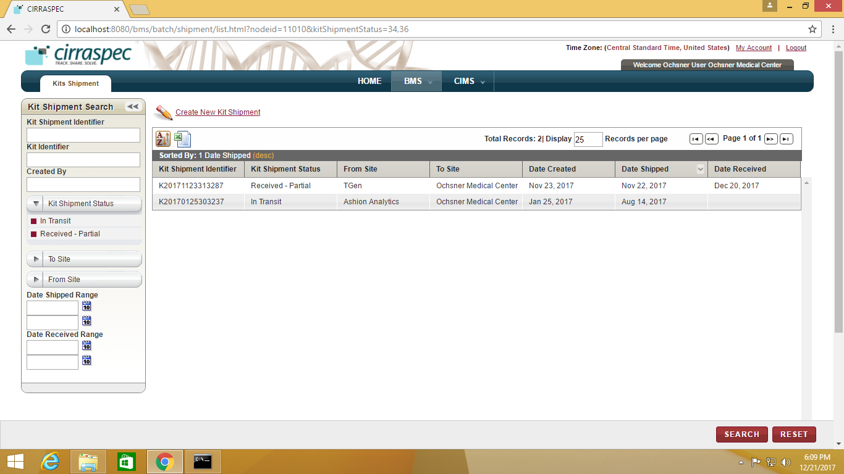

### Create New Kits Shipment to send to other Collection site

If required, To send a kit shipments to other collection site:

1. Log in to Cirraspec using your credentials.
2. Point to the arrow of the **BMS** tab, and then click **Kits Shipment**.   
   The **Kit Shipment Search** page appears.
3. Click on **Create New Kit Shipment**

**Create Kits Shipment** page appears.

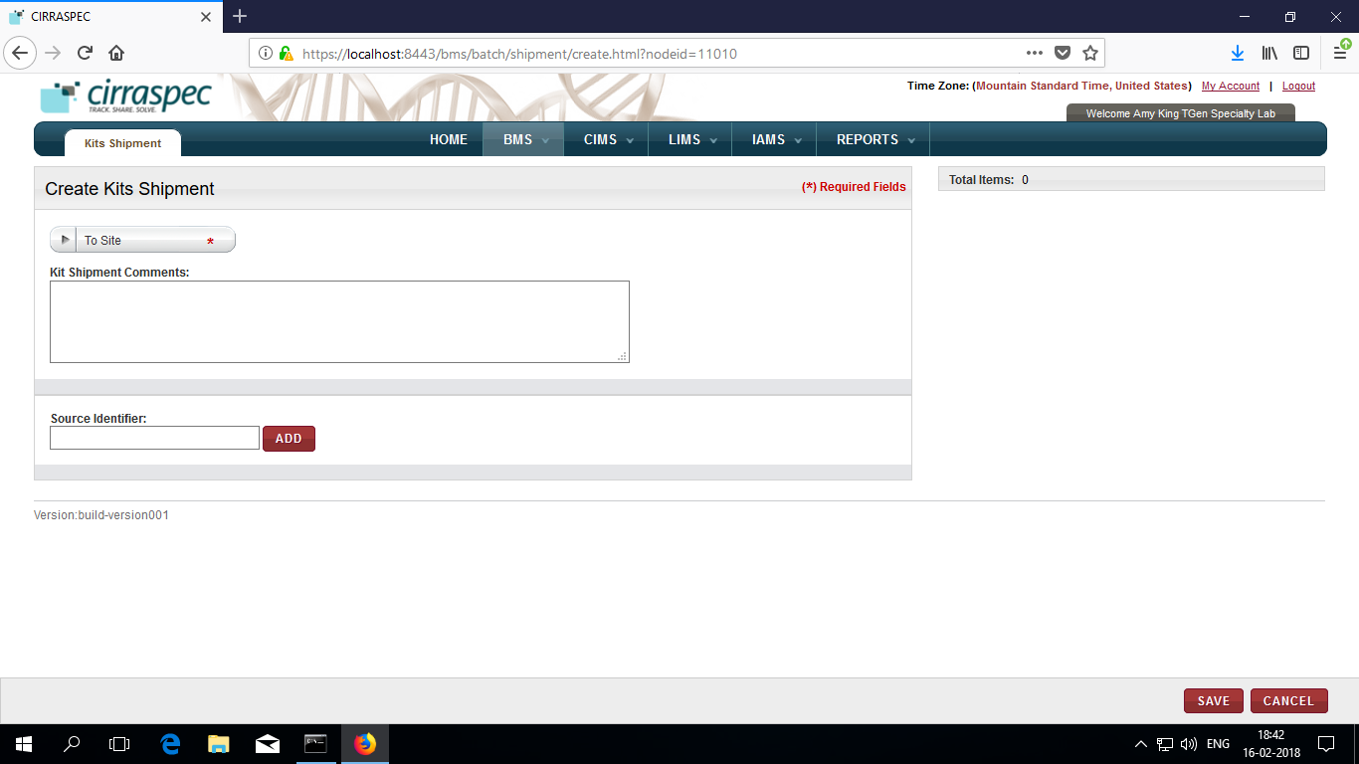

1. Select **To Site** from the dropdown.
2. Enter **Kit Shipment Comments** (Optional).

6. Enter or scan the Kit **Source identifier ( Kit Status** should be **In Stock)**

7. Click **ADD**

Kit appears on right pane

8. Click **SAVE**.

**View Kits Shipment page** appears**.**

**Shipment status : In Preparation** and **Kits status: Ready for Shipment** is seen.

# Creating/Maintaining a Subject Record

### Enrolling a Subject / Donor:

To enroll a subject to a Collection:

1. Point to the arrow of the **CIMS** tab, and then click **Subject Centric View**.

The **Subject Search** page appears.

1. Click the **Enroll New Subject** link

The **Create/Enroll Subject** page appears.

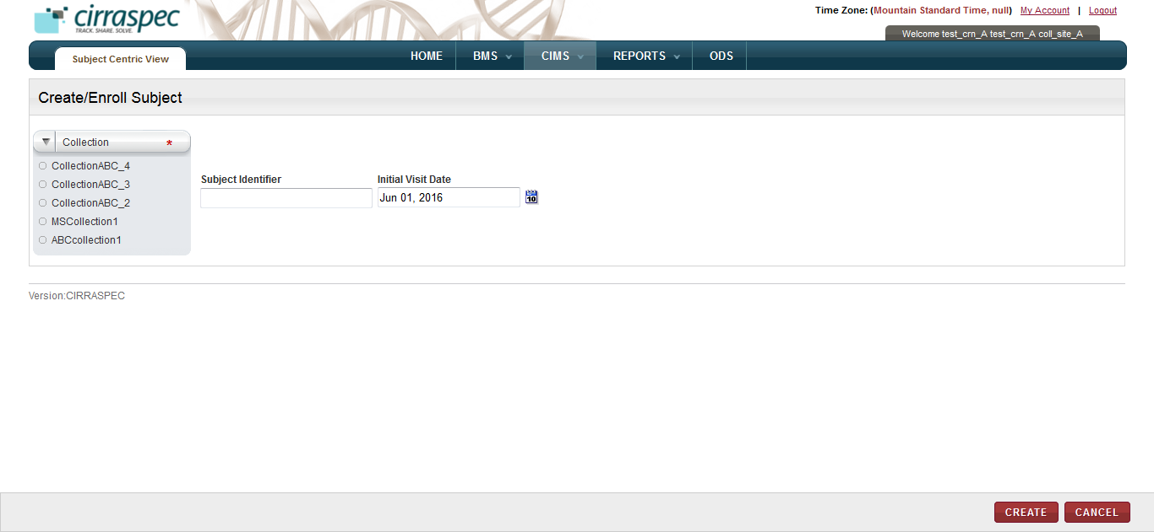

1. In the **Collection** list, Select the appropriate Collection.
2. Specify the **Subject Identifier**(optional) in the textbox provided.
3. Select the **Initial Visit Date** (optional) from the calendar. By default current date is displayed.
4. Click **CREATE**.

The subject is created and enrolled to the Collection you selected.

The subject identifier if not entered, is created by system as configured for the collection.

**Note:**

Subject Identifier: MRN, Internal or Other can be added for enrolled subject.

To add identifier, follow below steps:

1. Click on default subject identifier

2. Select the Identiifer Type from dropdown

3. Enter the Identifier

4. Click on Save.

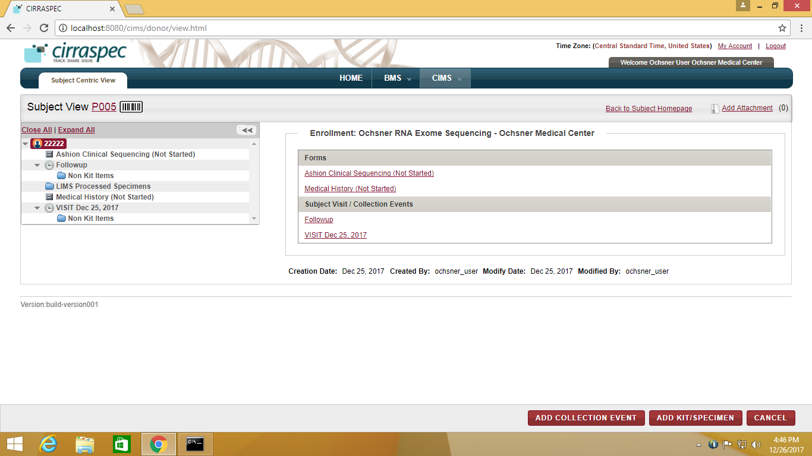

*Alternative Path:*

1. On Home Page, click on “Enroll subject record” link.

The Create/Enroll Subject page appears.

Follow same steps as above from step3 to enroll a subject

### Updating a Collection Event for a New Subject

To record the occurrence of a Collection Event:

1. Click the Collection Event link under the ‘**Subject Visit / Collection Events’ section** from the Subject Homepage

OR

In the hierarcy tree on the left, select/highlight the Collection Event node you want to update.  
The **View Collection Event** area appears on the right.  
  
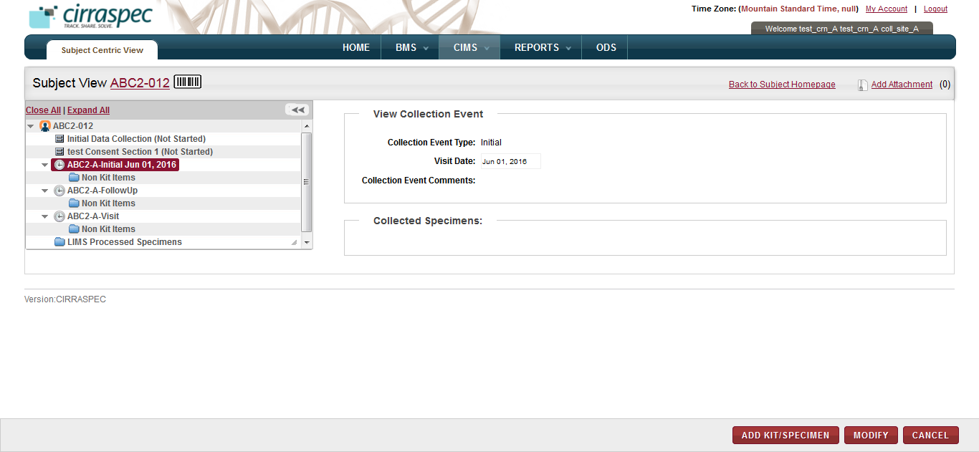

1. Click **MODIFY.**The appointment fields appear.
2. Select/change the **Visit Date** if required.
3. Input **Collection Event Comments**, if needed.
4. Click **SAVE**.The Collection Event information is saved.

### Assigning a Kit to a Subject

To assign a kit to a collection event for the subject:

1. Click the Collection Event link under the ‘**Subject Visit / Collection Events’ section** from the Subject Homepage

OR

In the hierarcy tree on the left, select/highlight the Collection Event node for which you want to assign a kit.

The **View Collection Event** area appears on the right.

1. Click **ADD/KIT SPECIMEN** button.

The ‘**Add Kit/Specimen**’ pop-up is displayed. It shows the Collection Event pre-selected in the **Collection Event** dropdown:

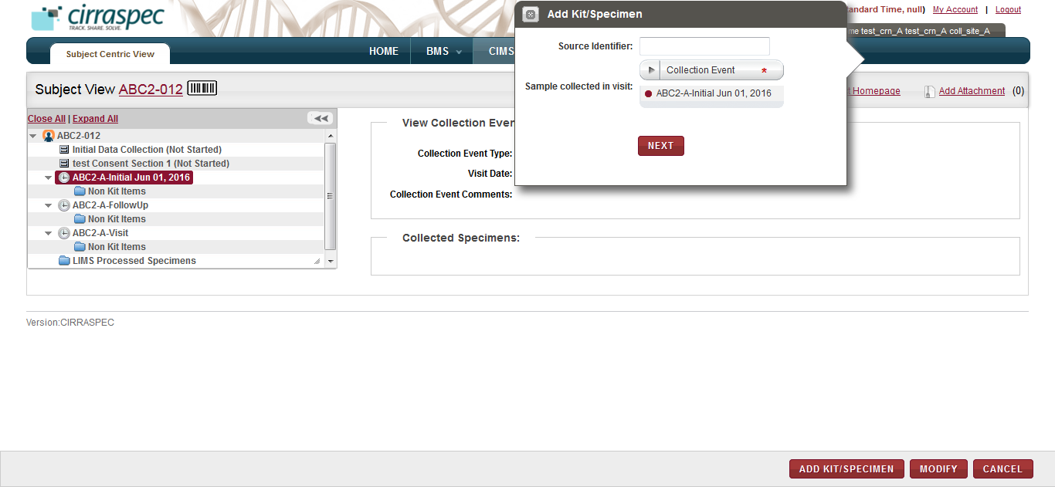

*Alternative Path:*

1. Click the **ADD KIT/SPECIMEN** button from the Subject Homepage
2. Select the required Collection Event from the dropdown on the ‘Add Kit/Specimen’ pop-up.
3. In the **Source Identifier** box, type the Identifier of the kit you want to assign, and then click **NEXT**.

The ‘**Assign Kits/Specimen’** page is displayed.

The kit content items appear on right panel in the kits cart under the Identifier box.

1. To delete a kit item from the kits cart, click the trash icon trash can icon for the appropriate item.

**Note:** To delete all the kit items, click the trash can icon trash can icon in the header row on extreme right.

1. To add a comment to a kit item:
2. Click the comments icon comments icon for the appropriate item.

The **Comments** window appears.

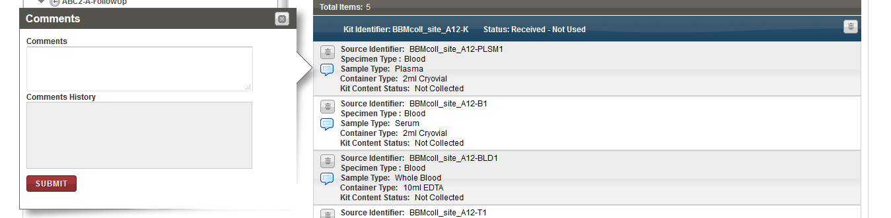

1. In the **Comments** box, type your comment regarding the kit item, and then click **SUBMIT**.

The comment is added to the kit item.

1. Click **SAVE**.   
   The kit is assigned to the Collection Event for this Subject.

**Note:**

1. Only one kit can be assigned to a collection event for a subject
2. Kit already assigned to a subject cannot be assigned to another subject.

### Collect Specimens as mentioned in the Assigned Kit

1. If you want to mark the kit content items as ‘Collected’ then do the following:
2. In the hierarcy tree on the left, select the kit node 

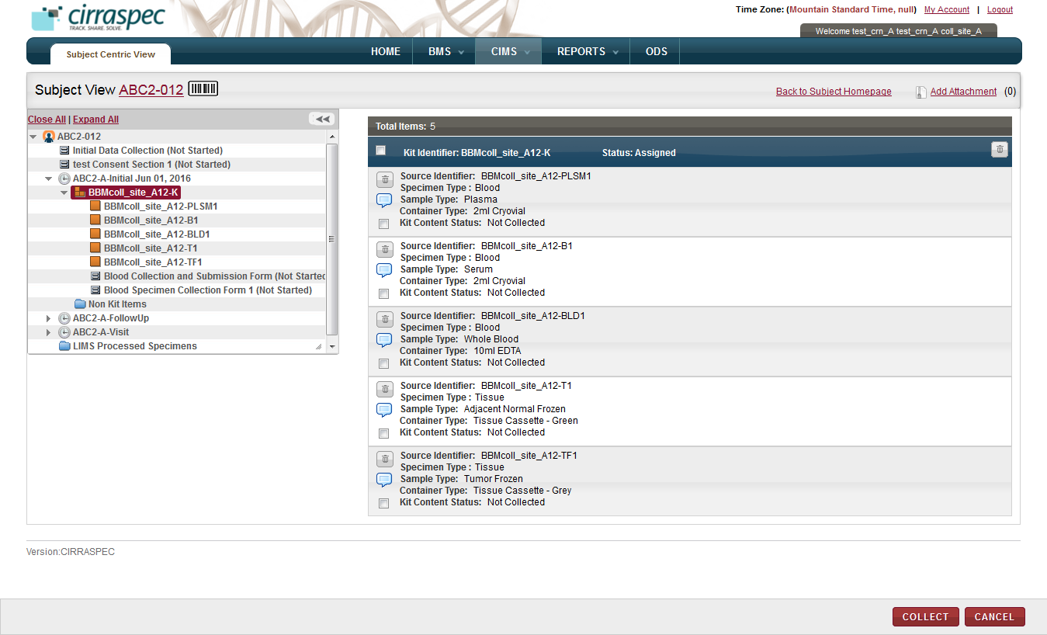

1. On the right panel, for kit items, Select the checkbox for every sample that you want to mark as **Collected**.

**Note:** Only a Collection Site user will be able to see the checkboxes.

To record the collection of all items,select the checkbox in the kit header.

1. Click **COLLECT**.   
   The **Collect** window appears.

**Note:** Fields that are marked with the red asterisk (*) are mandatory.

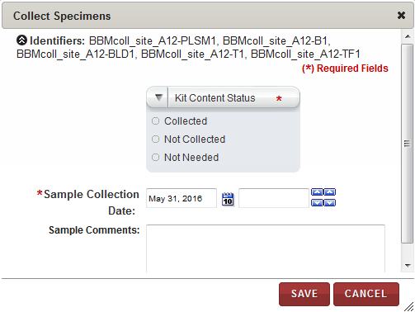

1. Click on the arrow for Kit Content Status
2. Select **Collected** as the **Kit Content Status**.
3. If the samples were collected on a date other than the date displayed in the **Sample Collection Date** box, click the date icon Search calendar and then select the collection date.
4. In the box beside the date, click the up and down arrow icons up and down arrow icons to indicate the collection time.
5. Type **Sample Comments**, if needed.
6. Click **SAVE**.  
   The **Kit Content Status** appears as **Collected** and is shown on the **Subject View** page.

**Note:** When the Kit Content Status changes, the Kit Status also changes:

* When the Kit Content Status for the first kit item is set to **Collected**, the kit status changes to **Collection Started**.
* When all kit items are designated as **Collected** or **Not Needed**, the kit status appears as **Completed**.

1. If kit content items are shown that are not needed, do the following:
2. Select the checkbox in front of each unused item. Then, click **COLLECT**.   
   The **Collect** window appears.
3. Click on the arrow for **Kit Content Status**.
4. Select **Not Needed** as the **Kit Content Status**.
5. Type the reason the item is not needed in **Sample Comments**.
6. Click **SAVE**.  
   The **Kit Content Status** of the unused kit item appears as **Not Needed.**

### 

### Completing Collection Forms for a Subject

To complete the Consent Form, Specimen Collection Form or any other dynamic form for a Subject:

1. From the **Subject Homepage** on the right side of the page, under the **Enrollment** section, click the link of the form section that you want to view.

OR

In the hierarchy tree structure on the left side of the page, click the form section node for which you want to fill up details.

Details of the selected form appear on the right side of the page.

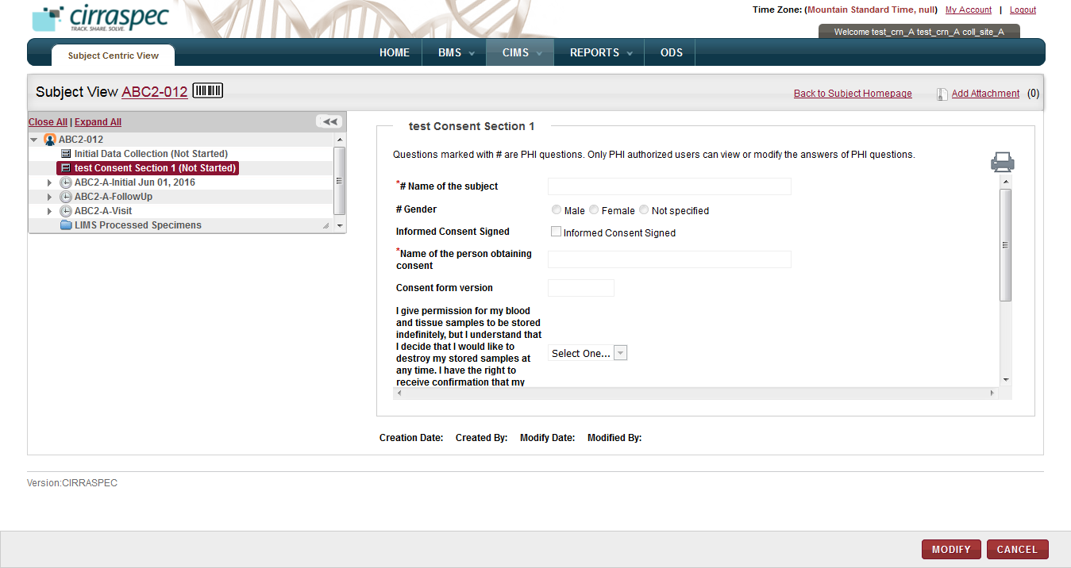

1. Click **MODIFY**.

The form data fields appear in modify mode.

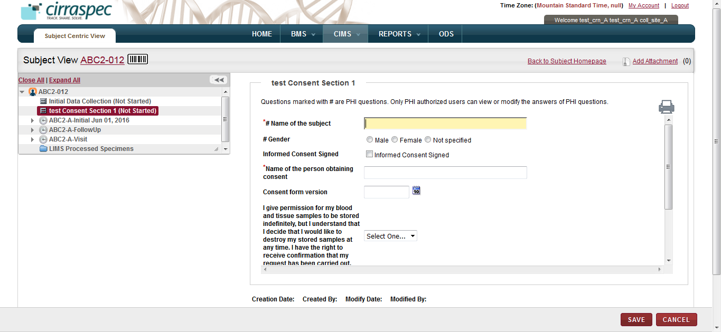

**Note**: PHI questions (if any) in the form would be marked with a hash sign (#).

If the form contains PHI questions, they would appear in a different fashion to the PHI and Non-PHI authorized users.

* PHI authorized users will be able to fill up answers for PHI as well as Non-PHI questions on clicking the MODIFY button.
* However, the Non-PHI authorized users will be able to fill up answers only for the Non-PHI questions.

The input fields for the PHI questions will appear greyed out when users clicks the MODIFY button.

Above screen shot shows how a form will appear for a PHI user. All the input fields will open up in the edit mode once user clicks MODIFY button.

Following is a screen shot showing how the form will appear for a Non-PHI user:

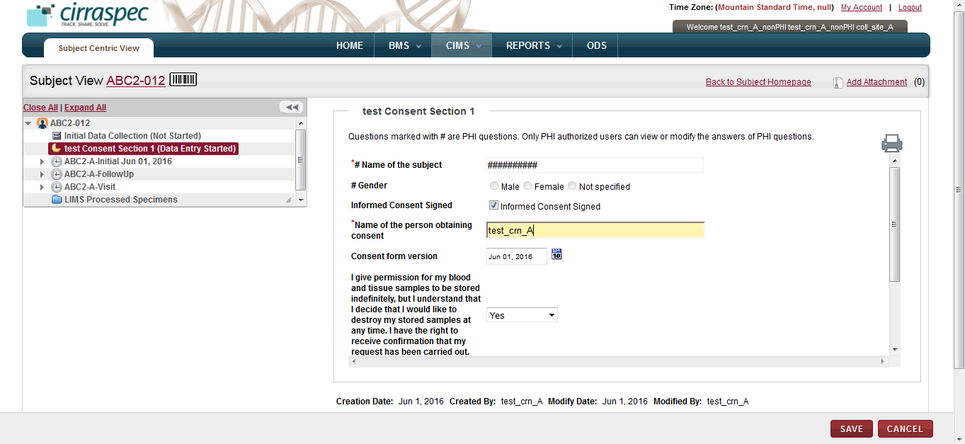

Notice how the questions marked with hash sign (#) appear in the greyed out mode in the above screen shot for the Non-PHI user.

**Note**: If PHI questions of the form have already been answered then:

* PHI authorized users will be able to view the answers.
* However, the Non-PHI authorized users will not the able to view the answers.
  + The answers will be blanked out in case of check-boxes, radio buttons and dropdowns.
  + The answers will be hashed out in case of textboxes.

1. Enter the form data and then click **SAVE**.

The changes are saved and the form section status appears as **Data Entry Started**.

**Note**:

* If a form contains PHI questions which have been marked mandatory (as in the above case), then the PHI users are not allowed to SAVE the form if the questions have not been answered.
* However the Non-PHI users are allowed to SAVE such a form in any case since they will not be able to fill up answers for the mandatory PHI questions.

1. If the form is complete, do the following:
2. Click **DATA ENTRY COMPLETED**.

The status of the form appears as **Data Entry Completed**.

1. Click **APPROVE**.

The status of the form appears as **Approved**.

**Note**: If the form has one or more PHI questions, then these options would not be shown to the Non-PHI authorized user since he would never be able to know if the answers to PHI questions have been filled up or not and hence will not be in a state to comment on the form status.

1. To view and/or print the form, click the **print icon** .  
   The form appears in a new window.   
   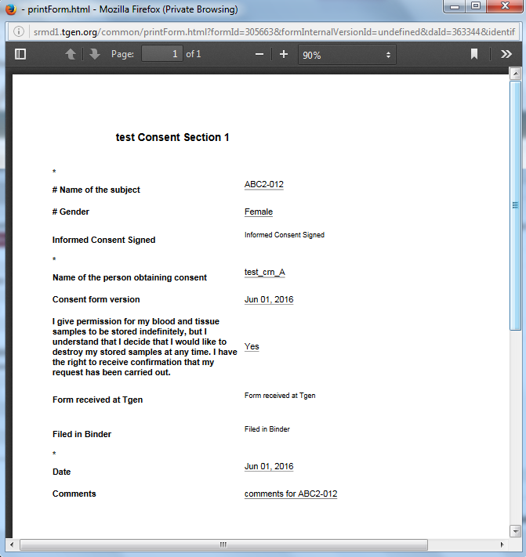
2. Click the **arrow icon **, and then select **Print** on the list of options.

The **Print** window appears. You can select a printer, specify number of copies and pages to print.

### Adding an Unscheduled Collection Event for a Subject

To add an unscheduled Collection Event (e.g. unscheduled follow-up visit):

1. Point to the arrow of the **CIMS** tab, and then click **Subject Centric View**.

The **Subject Search** page appears.

1. Click **SEARCH**.

The Subject Search page displays a list of Subjects.

1. Click the row of the Subject that you want to update.

The **Subject View** page appears.

1. Click **ADD COLLECTION EVENT** button at the right bottom of the page

The **Add Collection Event** area appears on the right.  
  
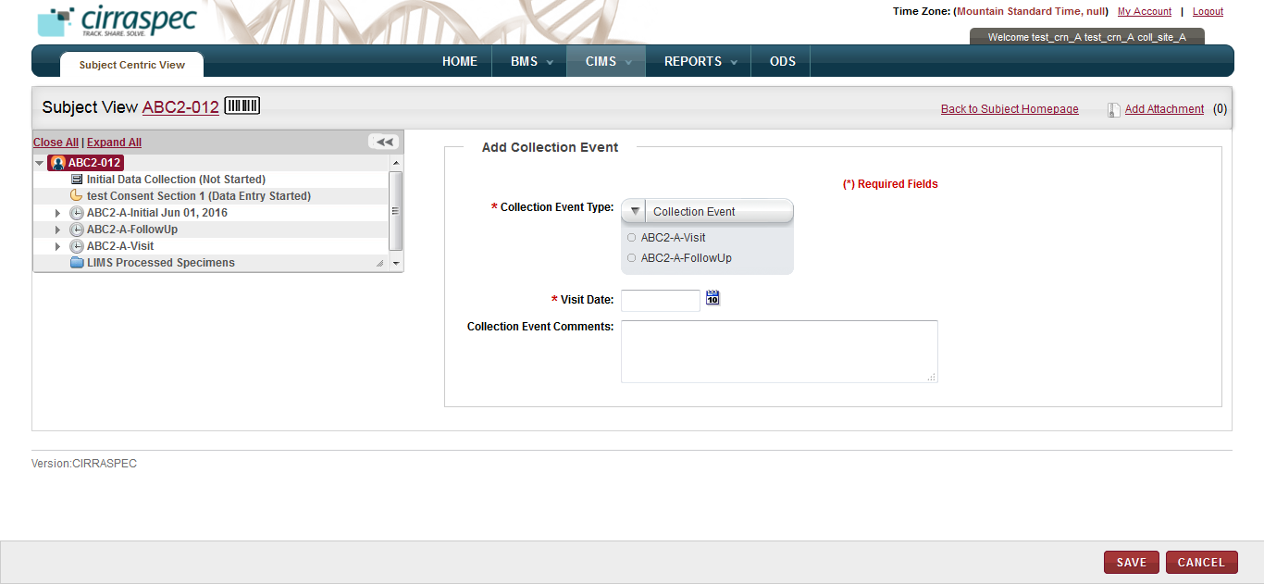

1. Select the **Collection Event Type**.
2. Select the **Visit Date**.
3. Input **Collection Event Comments**, if needed.
4. Click **SAVE**.The Collection Event information is saved.

**Note**: Refer to **Assigning a Kit to a Subject** to assign a kit for the added collection event.

# Recording the Use of a Kit

In case, specimen collection is not done on subject screen, you can alternatively follow the below process to collect specimens and record the use of kit.

### Viewing a List of Kits

To view a list of kits:

1. Log on to the application using your login credentials.
2. Point to the arrow of the **BMS** tab, and then click **Kits Inventory.**   
   The **Kit Search** page appears.
3. Click **SEARCH**.  
   The kit search page displays a list of kits.

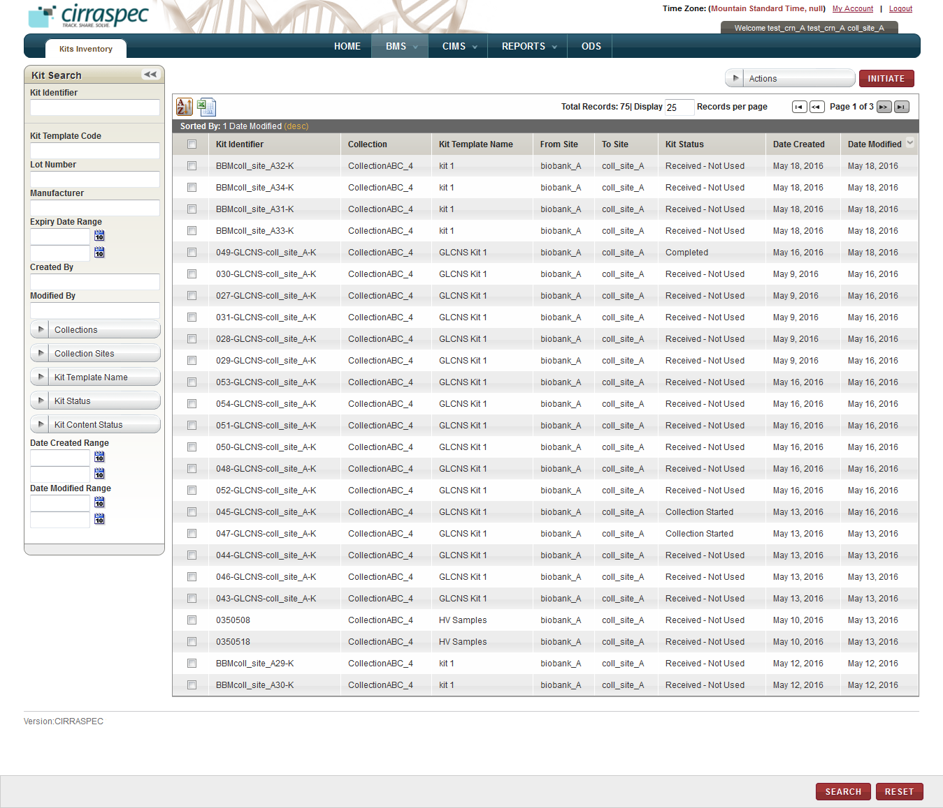

1. To search for a specific kit, type the Identifier of the kit in the **Kit Identifier** box. Or specify other search criteria by completing one or more fields in the **Kit Search** pane.

**Note:**

* You can use one field or a combination of fields to search for a kit.
* You can type the full or partial value in a search field along with an asterisk (*) before or after the partial value. For example, if you type **02\***, you obtain records that begin with 02. If you type **\*02**, you obtain records that end with 02

1. Click **SEARCH**.

### Recording the Use of a Kit

To record the use of a kit:

1. On the **Kits Search** page, click the row of the kit that you want to modify.   
   The **View Kit** page appears with the details of the kit that you selected

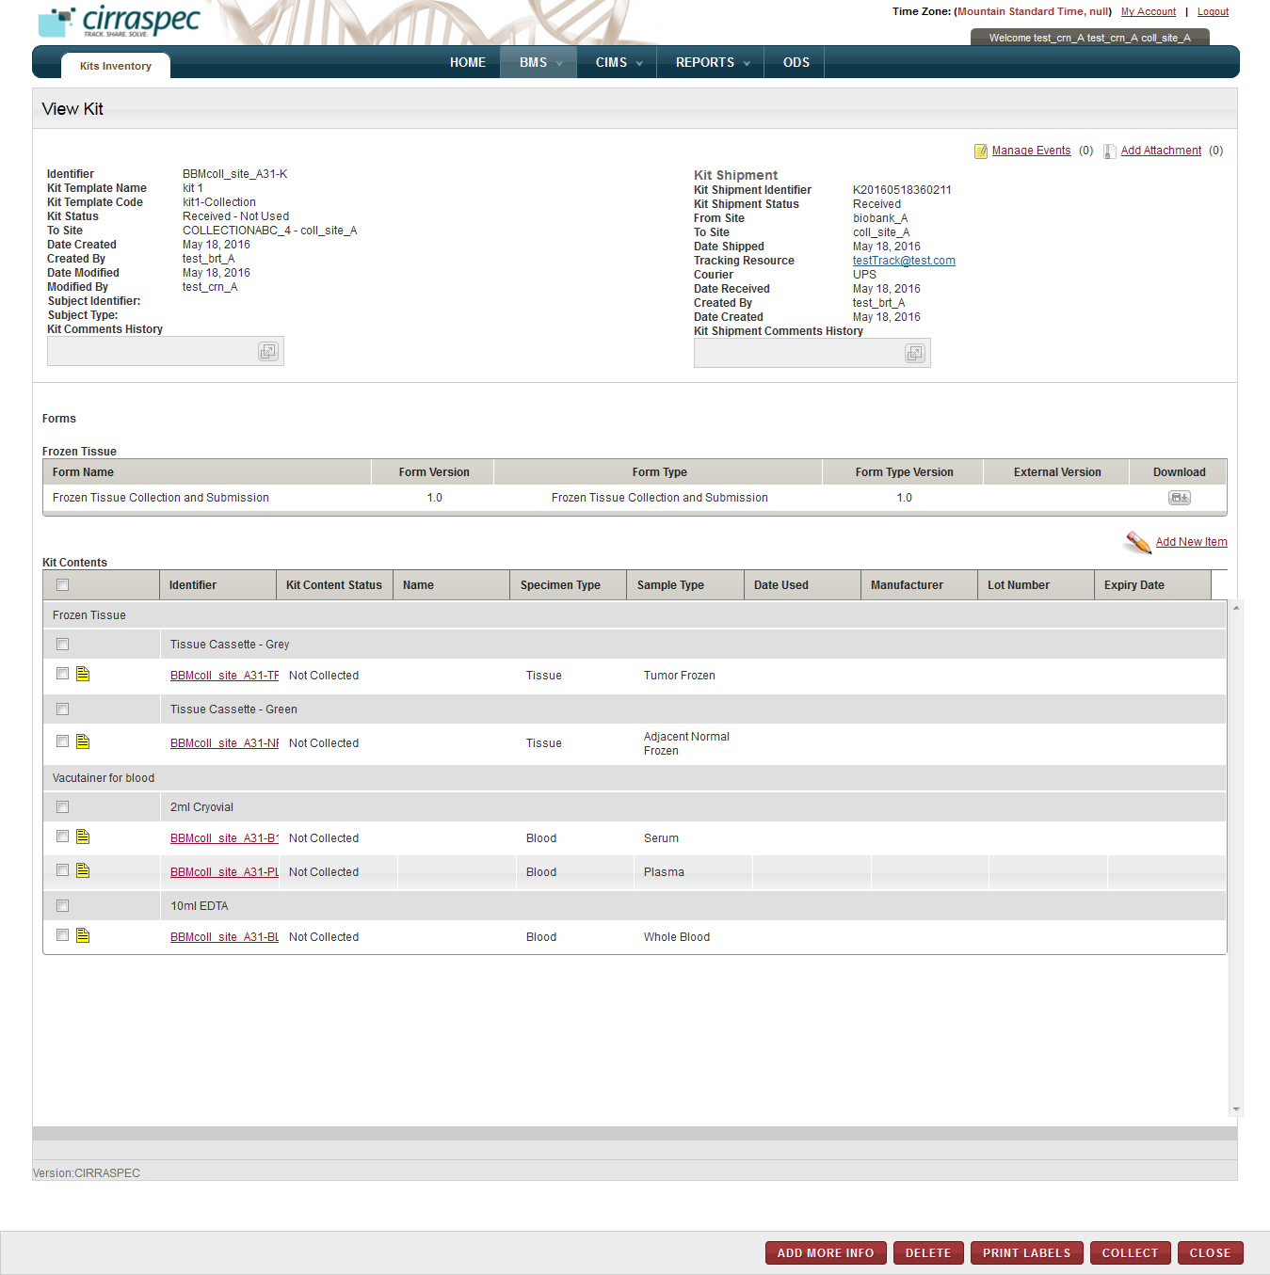

1. If a replacement tube from “bulk kits” supply was used, do the following to add the replacement to the **Kit Contents** list:
2. Click the **ADD NEW ITEM** link (above Kit Contents list on the right side).  
   The **Add New Item** window appears.

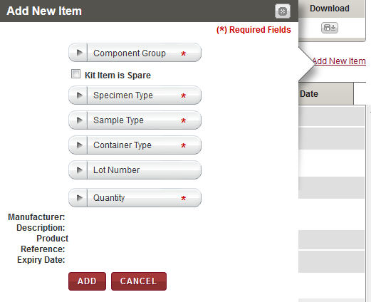

Enter the following information in the pop-up window:

**Note:** Fields that are marked with the red asterisk (*) are mandatory.

| **Field** | **Description** |
| --- | --- |
| **Component Group**\* | Click the appropriate component group to which the item is to be added. |
| **Kit Item is Spare** | If the item to be added to the kit is a spare item, select this check box.  **Note:** If you select this check box, skip the Specimen Type, Sample Type, Container Type and Lot Number fields below. |
| **Specimen Type**\* | Click the appropriate specimen type for the new item.  **Note:** This field is inactivated when adding a spare item. |
| **Sample Type**\* | Click the appropriate sample type for the new item.  **Note:** This field is inactivated when adding a spare item. |
| **Container Type**\* | Click the appropriate container type for the new item.  **Note:** This field is inactivated when adding a spare item. |
| **Lot Number** | If there is a lot number associated with the new item, click the appropriate product lot number for the new item  **Note:**   * This field is inactivated when adding a spare item. * Selecting a lot number automatically populates the manufacturer and product related text fields displayed at the bottom of the window. * This field only displays lot numbers already on record. If a desired lot number is *not* displayed, send an email to [cirraspec@tgen.org](mailto:Bio4Dhelp@tgen.org) with the lot number(s) and product information to be added to the application. |
| **Quantity**\* | Click the appropriate number of kit content items to be added. |
| **Spare Item Name**\* | If the item is a spare item, type a name for the item. |

1. Click **ADD**.

The **Electronic Signature** window appears.

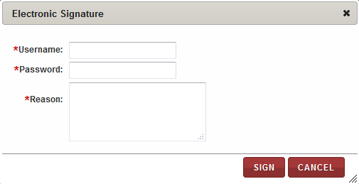

Enter your username, your password and a reason for this action.

Click **SIGN**.

The pop-up window closes and the new kit item is added to the kit contents on the **View Kit** page.

1. To print a barcode label for the new item, select the check box in front of the new item in the **Kit Contents** list. Then click **PRINT LABELS**.  
   The print labels window appears.

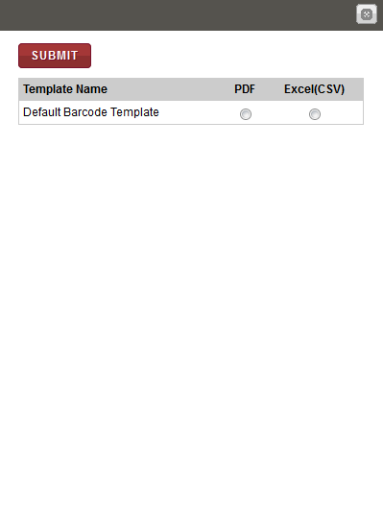

Click **PDF** and then **SUBMIT**.  
The image of the bar code label appears in the pop-up window.

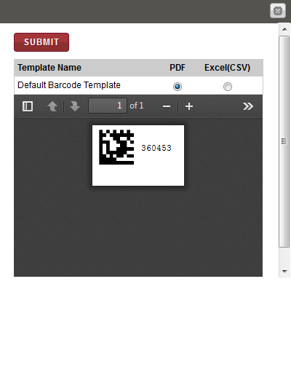

Click on the printer option (accessible when user clicks the ‘>>’ icon) to print the label.

1. If any kit content items will not be used, select the check box in front of each unused item. Then, click **COLLECT.**   
   The **Collect** window appears.

**Note:** Fields that are marked with the red asterisk (*) are mandatory.

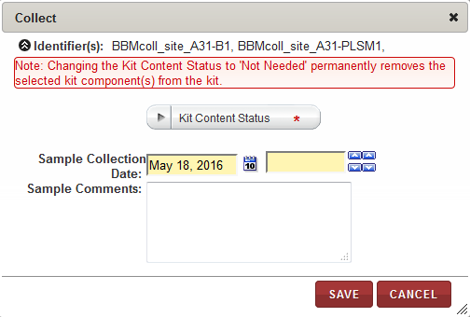

1. Select **Not Needed** as the **Kit Content Status**.
2. Type the reason the item is not needed in **Sample Comments**.
3. Click **SAVE**.  
   The **Kit Content Status** of the unused kit item appears as **Not Needed** on the **View Kit** page**.**
4. To record collection, select the checkbox in front all used items (excluding spare items) on the **Kit Contents** list.
5. Click **COLLECT**.

The **Collect** window appears.

**Note:** Fields that are marked with the red asterisk (*) are mandatory.

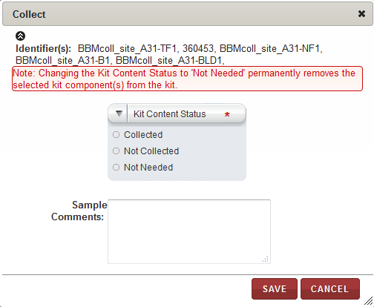

1. Select **Collected** as the **Kit Content Status**.
2. If the samples were collected on a date other than the date displayed in the **Sample Collection Date** box, click the date icon Search calendar and then select the collection date.
3. In the box beside the date, click the up and down arrow icons up and down arrow icons to indicate the collection time.
4. Type **Sample Comments** as needed.
5. Click **SAVE**.  
   The **Kit Content Status** appears as **Collected** and is shown on the **View Kit** page.

**Note:** When the Kit Content Status changes, the Kit Status also changes:

* When the Kit Content Status for the first kit item is set to **Collected**, the Kit Status changes to **Collection Started**.
* When all kit items are designated as **Collected** or **Not Needed**, the Kit Status appears as **Completed**.

# Creating and Sending a Shipment of Collected Biospecimens

### Creating a Shipment

To create a shipment of collected biospecimens:

1. Point to the arrow of the **BMS** tab, and then click **Shipments**.

The **Shipment Search** page appears.

1. Click the **Create New Shipment** link.

The **Create Shipment** page appears.

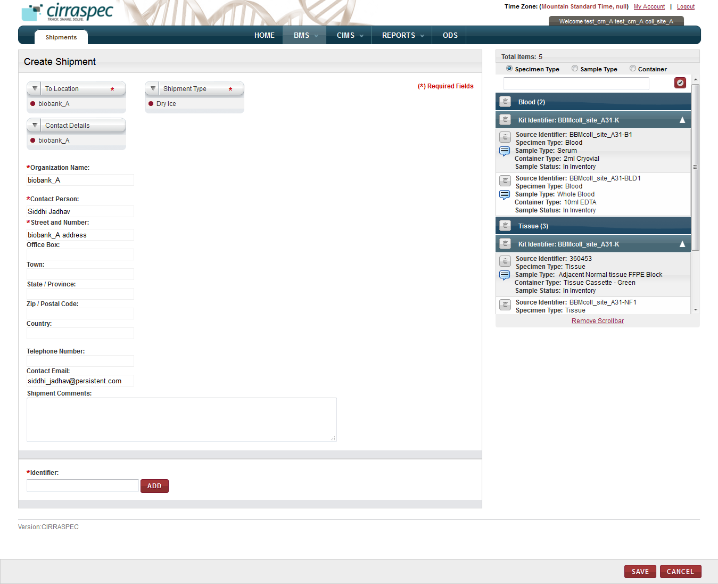

*Shipment Cart*

1. Enter appropriate information in each field. Following table lists each field and its description.

**Note:** Fields that are marked with the red asterisk (*) are mandatory.

| **Field** | **Description** |
| --- | --- |
| **To Location**\* | Click the site you want the shipment sent to. |
| **Contact Details** | Click the appropriate contact.  **Note:** If you click a known contact, rest of the fields are populated with data related to that contact. |
| **Organization Name**\* | Type name of the organization associated with the specified delivery location. |
| **Contact Person**\* | Type name of the contact. |
| **Street and Number**\* | Type street address for the contact. |
| **Office Box** | Type office box or mail stop for the contact’s mailing address, if applicable. |
| **Town** | Type town or city of the contact’s mailing address. |
| **State / Province** | Type state or province of the contact’s mailing address. |
| **Zip / Postal Code** | Type postal code of the contact’s mailing address. |
| **Country** | Type country of the contacts mailing address if other than USA. |
| **Telephone Number** | Type contact’s telephone number, if known. |
| **Contact Email** | Type contact’s email address, if known. |
| **Shipment Type**\* | Click appropriate shipment type. |
| **Shipment Comments** | Type comments, as needed. |
| **Identifier\*** | Type or scan the Identifier of the kit or the collected biospecimen you want to add to the shipment and click **ADD**. Repeat for each kit or biospecimen you want added to the shipment (one kit or biospecimen at a time).  The specified biospecimens appear in the shipment cart (right side).  **Note:** If a Kit Identifier is used, all biospecimens associated with this kit appear in the shipment cart. |

1. To add a collected biospecimen to the shipment with an identifier that is not currently in system:
2. In the **Identifier** box, type appropriate identifier and click **ADD**.

The **Create Inventory** window appears.

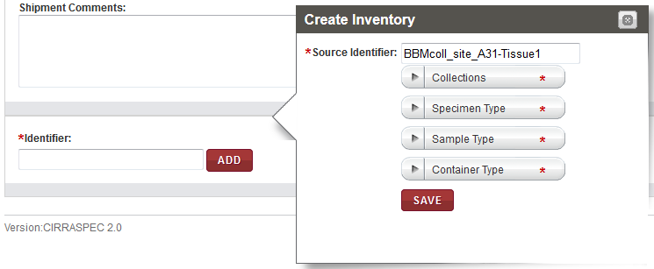

1. Enter appropriate information in each field. Following table lists each field and its description.

**Note:** Fields that are marked with the red asterisk (*) are mandatory.

| **Field** | **Description** |
| --- | --- |
| **Source Identifier**\* | The identifier that you typed in the Source Identifier field on Create Shipment screen appears here. |
| **Collections**\* | Click appropriate Collection to which this biospecimen should be assigned |
| **Specimen Type**\* | Click appropriate specimen type for this biospecimen. |
| **Sample Type**\* | Click appropriate sample type for this biospecimen. |
| **Container Type**\* | Click appropriate container type for this biospecimen. |

1. Click **SAVE**.

The biospecimen appears in the shipment cart.

1. To delete a biospecimen from the shipment cart:
2. Click the trash can icon trash can icon for the appropriate biospecimen.

**Note:** To delete all the biospecimens, click the trash can icon trash can icon on the blue bar.

A confirmation window appears.

1. Click **OK**.

The biospecimen is deleted.

1. To add a comment for a biospecimen:
2. In the **Total Items** area, click the comments icon comments icon for the appropriate biospecimen.  
   The **Comments** window appears.

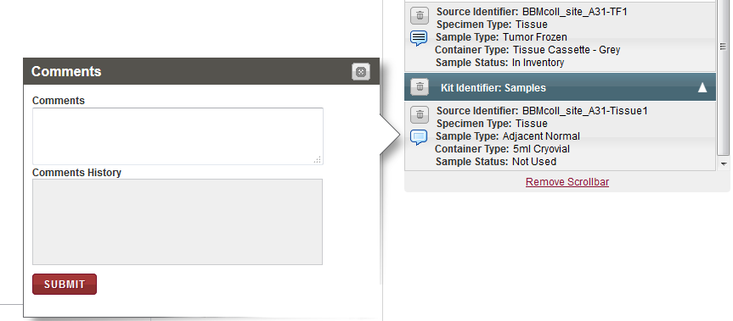

1. In the **Comments** box, type appropriate comments for this biospecimen.
2. Click **SUBMIT**.

The comment is saved.

1. Click **SAVE**.

The shipment is created. On the **View Shipment** page,

* The status of all biospecimens appears as **Pre-shipment**
* The shipment status appears as **In Preparation**

1. To print a shipment report, click **Print**.   
   The **Print** options window appears.

* To print a summary list of the shipment contents, click **Print List**.
* To print a shipment manifest with detailed shipment and content information, click **Print Manifest**.

The shipment list or manifest appears in a new window.

1. View, print and/or save the file, as needed.   
   **Note**: Hover the cursor over the icons in the horizontal and vertical navigation bars to identify tools for viewing multiple pages, printing the report and saving the file to your desktop.

### Modifying a Shipment

To modify a shipment of collected biospecimens before sending it:

1. Point to the arrow of the **BMS** tab, and then click **Shipments**.

The **Shipment Search** page appears.

1. Click **SEARCH**.

The shipment search page displays a list of shipments.

1. Click the row of the shipment that you want to modify.

The **View Shipment** page appears.

1. Click **Modify**.

The **Modify Shipment** page appears.

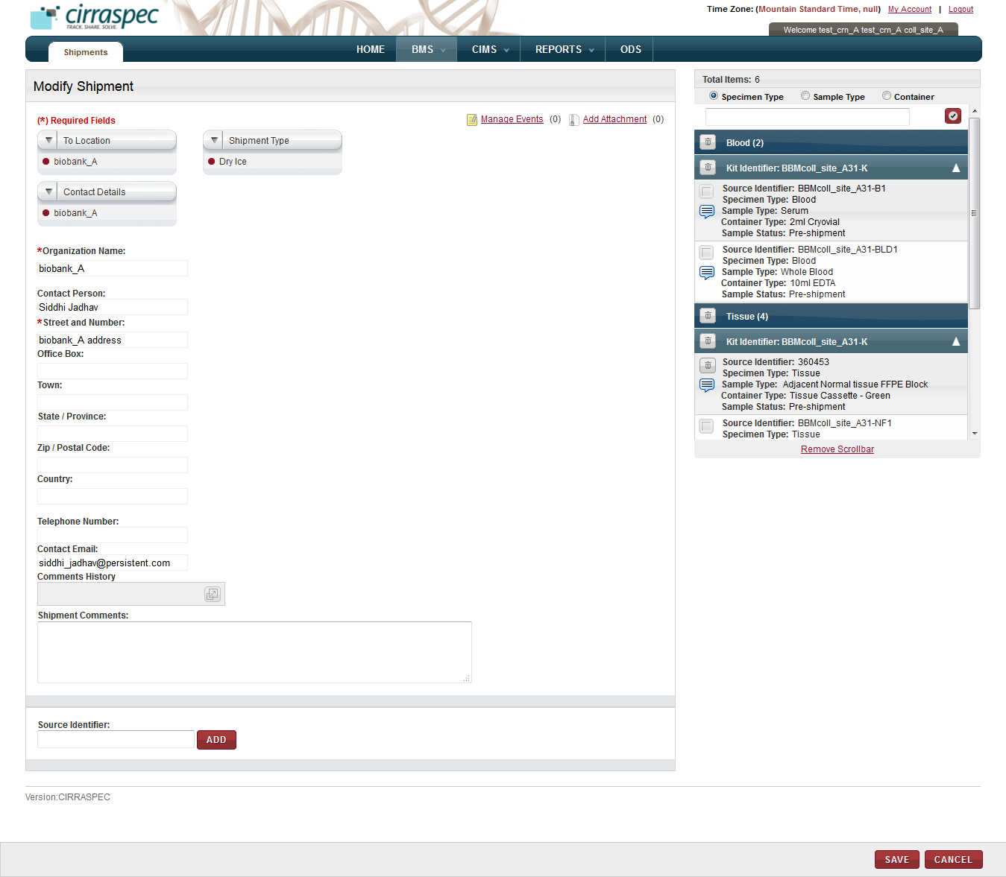

1. Make changes to the **To Location**, **Shipment Type** and **Contact Details** fields, as needed.
2. To add a collected biospecimen to the shipment with an identifier that is not currently in the system:
3. In the **Identifier** box, type appropriate identifier and click **ADD**.

The **Create Inventory** window appears.

1. Enter appropriate information in each field in the pop-up.
2. Click **SAVE**.

The biospecimen appears in the shipment cart.

1. To delete a biospecimen from the shipment cart:
2. Click the trash can icon trash can icon for the appropriate biospecimen.

**Note:** To delete all biospecimens, click the trash can icon trash can icon on the blue bar.

A confirmation window appears.

1. Click **OK**.

The biospecimen is deleted.

1. To add a comment for a biospecimen:
2. In the **Total Items** area, click the comments icon comments icon for the appropriate biospecimen.  
   The **Comments** window appears.
3. In the **Comments** box, type appropriate comments for this biospecimen.
4. Click **SUBMIT**.

The comment is saved.

1. Click **SAVE**.

The shipment is modified.

### Deleting a Shipment

To delete a shipment of collected biospecimens before sending it:

1. Point to the arrow of the **BMS** tab, and then click **Shipments**.

The **Shipment Search** page appears.

1. Click **SEARCH**.

The shipment search page displays a list of shipments.

1. Click the row of the shipment that you want to delete.   
   The **View Shipment** page appears.
2. Click **Delete**.   
   A confirmationwindow appears.
3. Click **OK**.   
   The shipment is deleted and the biospecimens previously associated with the shipment return to inventory**.**

### 

### Sending a Shipment of Collected Samples

To send a shipment of collected samples:

1. Point to the arrow of the **BMS** tab, and then click **Shipments**.

The **Shipment Search** page appears.

1. Click **SEARCH**.

The shipment search page displays a list of shipments.

1. Click the row of the shipment that you want to send.

The **View Shipment** page appears.

1. Click **SEND**.

The **Send Shipment** page appears.

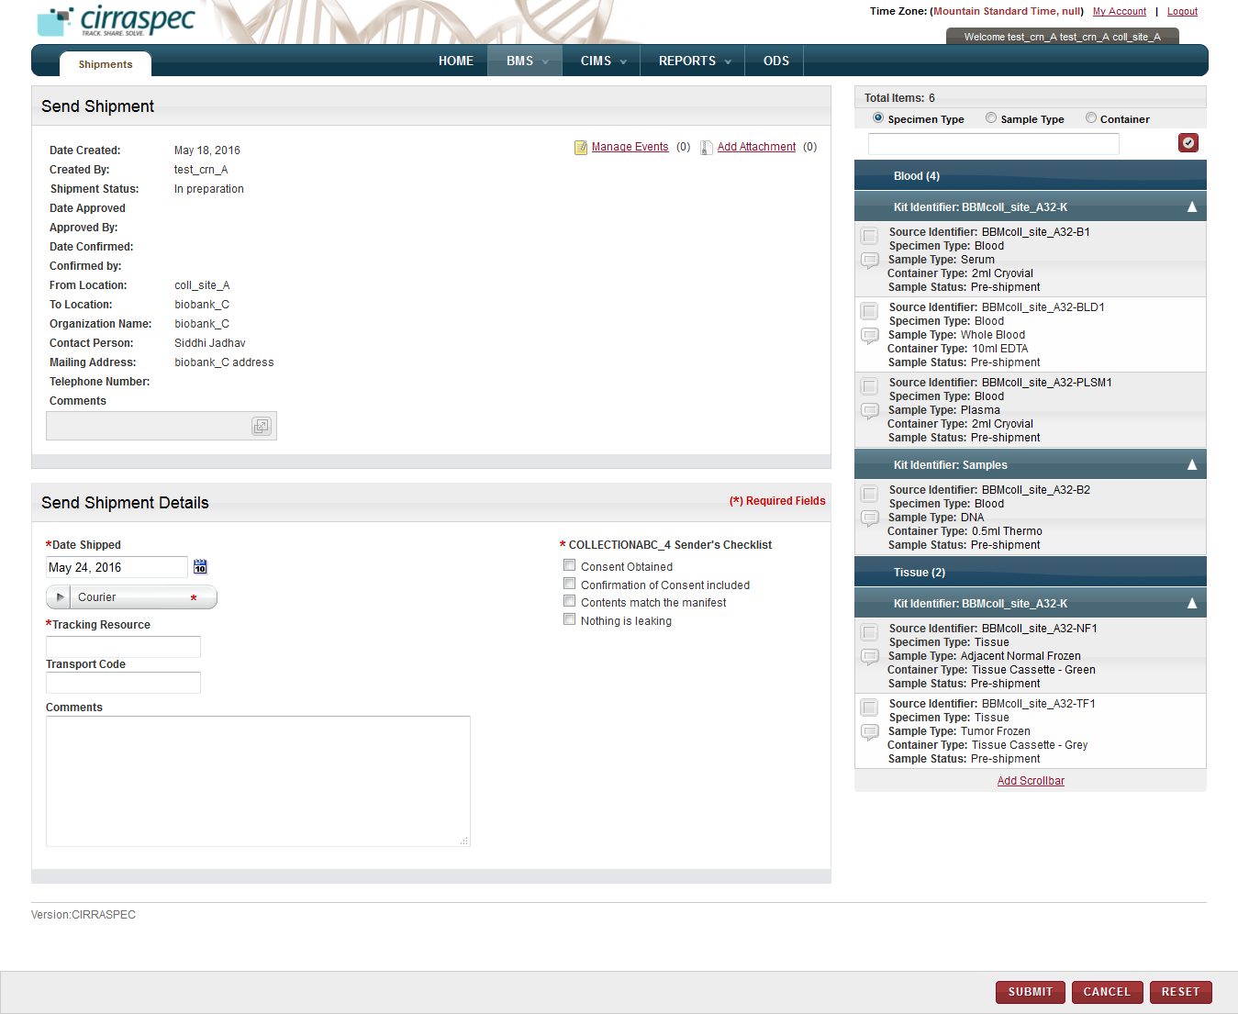

1. In the **Send Shipment Details** area, enter appropriate information in each field. Following table lists each field and its description.

**Note:** Fields that are marked with the red asterisk (*) are mandatory.

| **Field** | **Description** |
| --- | --- |
| **Date Shipped**\* | Click the date icon Search calendar, and then click the date when you will send the shipment.  The date appears in the **Date Shipped** box. |
| **Courier**\* | Click appropriate shipping courier. |
| **Tracking Resource**\* | Type shipping courier’s tracking number. |
| **Transport Code** | Type transport code, if applicable. |
| **Comments** | Type comments, as needed. |
| **Sender’s Checklist** | Make sure all the checkboxes are selected and the respective actions have been taken. |

1. Click **SUBMIT**.

The shipment status and the biospecimens’ status changes to **In Transit** on the **View Shipment** page.

*Alternative Path:*

1. Click on the “Ship specimens” link on Home Page

The **View Shipment** page appears.

1. Follow above steps from step 3 to Ship the specimens.

### Send Kits Shipment to other Collection site

Follow above steps to search Kits shipment prepared to send to other Collection site and send Shipment